Create a new React Application with the name “myfirstreact”, Run the application to print “welcome to the first session of React” as heading of that page.

**App.js**

function App() {

  return (

    <h1>Welcome the first session of React</h1>

  );

}

export default App;

**Output Screenshot:**

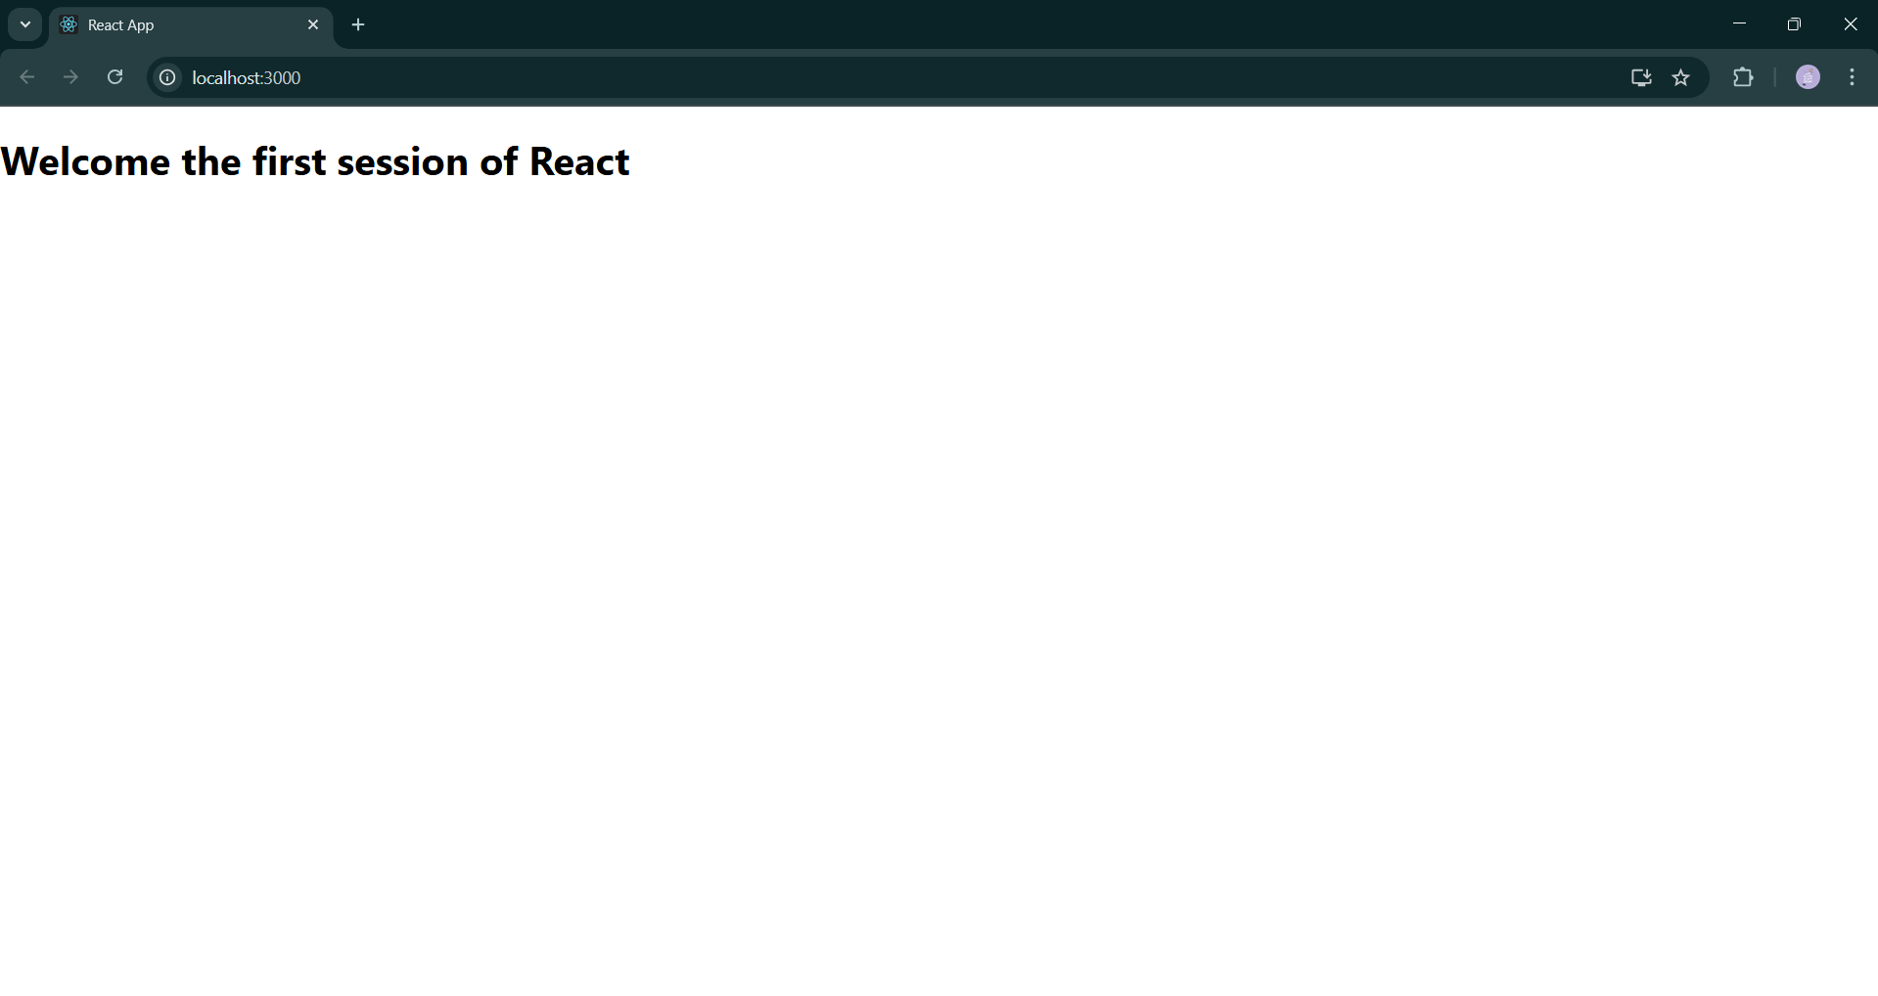

Create a react app for Student Management Portal named StudentApp and create a component named Home which will display the Message “Welcome to the Home page of Student Management Portal”. Create another component named About and display the Message “Welcome to the About page of the Student Management Portal”. Create a third component named Contact and display the Message “Welcome to the Contact page of the Student Management Portal”. Call all the three components.

**Home.js**

import React, { Component } from 'react';

class Home extends Component {

render() {

return (

<div>

<h3>Welcome to the Home Page of Student Management Portal</h3>

</div>

);

}

}

export default Home;

**About.js**

import React, { Component } from 'react';

class About extends Component {

render() {

return (

<div>

<h3>Welcome to the About Page of Student Management Portal</h3>

</div>

);

}

}

export default About;

**Contact.js**

import React, { Component } from 'react';

class Contact extends Component {

render() {

return (

<div>

<h3>Welcome to the Contact Page of Student Management Portal</h3>

</div>

);

}

}

export default Contact;

**App.js**

import React from 'react';

import './App.css';

import Home from './Components/Home';

import About from './Components/About';

import Contact from './Components/Contact';

function App() {

return (

<div className="App">

<Home />

<About />

<Contact />

</div>

);

}

export default App;

**Output screenshot:**

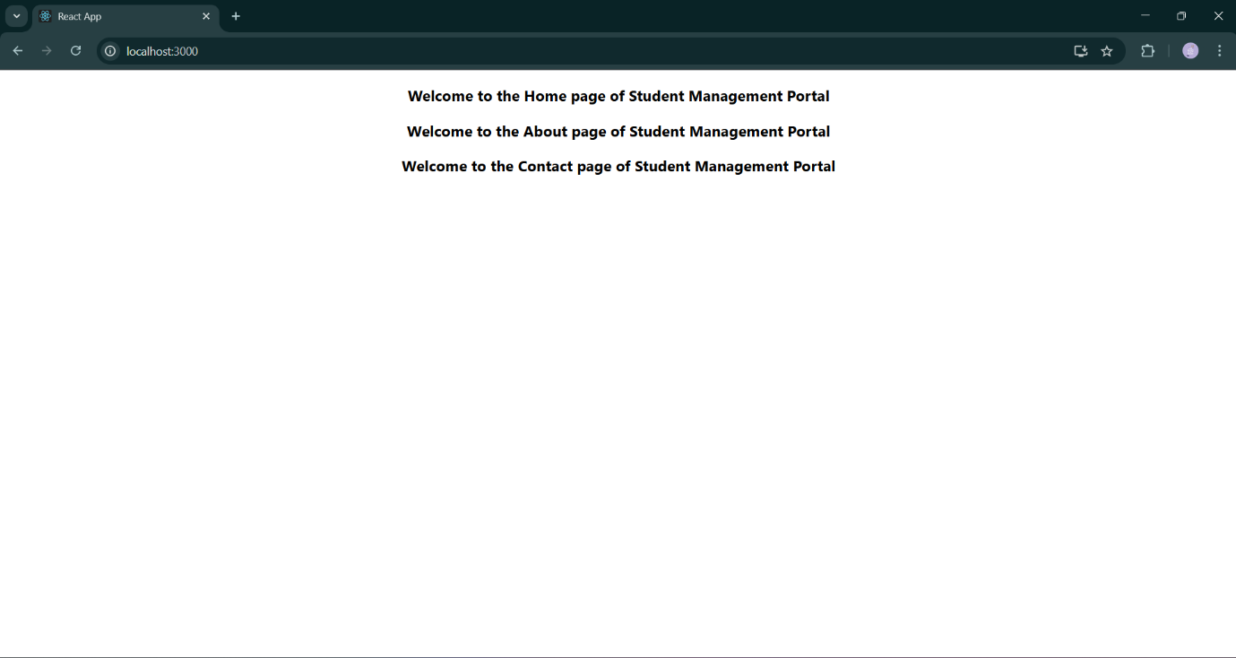

Create a react app for Student Management Portal named scorecalculatorapp and create a function component named “CalculateScore” which will accept Name, School, Total and goal in order to calculate the average score of a student and display the same.

**CalculateScore.js**

import './Stylesheets/mystyle.css'

const percentToDecimal = (decimal) => {

return (decimal.toFixed(2) + '%')

}

const calcScore = (total, goal) => {

return percentToDecimal(total / goal)

}

export const CalculateScore = ({ Name, School, total, goal }) => (

<div className="formatstyle">

<h1><font color="Brown">Student Details:</font></h1>

<div className="Name">

<b><span> Name: </span></b>

<span>{Name}</span>

</div>

<div className="School">

<b><span> School: </span></b>

<span>{School}</span>

</div>

<div className="Total">

<b><span>Total:</span></b>

<span>{total}</span>

<span> Marks</span>

</div>

<div className="Score">

<b>Score:</b>

<span>

{calcScore(

total,

goal

)}

</span>

</div>

</div>

)

**mystyle.css**

.Name {

font-weight: 300;

color: blue;

}

.School {

color: crimson;

}

.Total {

color: darkmagenta;

}

.formatstyle {

text-align: center;

font-size: large;

}

.Score {

color: forestgreen;

}

**App.js**

import { CalculateScore } from '../src/components/CalculateScore';

function App() {

return (

<div>

<CalculateScore

Name={"Steeve"}

School={"DNV Public School"}

total={284}

goal={3}

/>

</div>

);

}

export default App;

**Output Screenshot:**

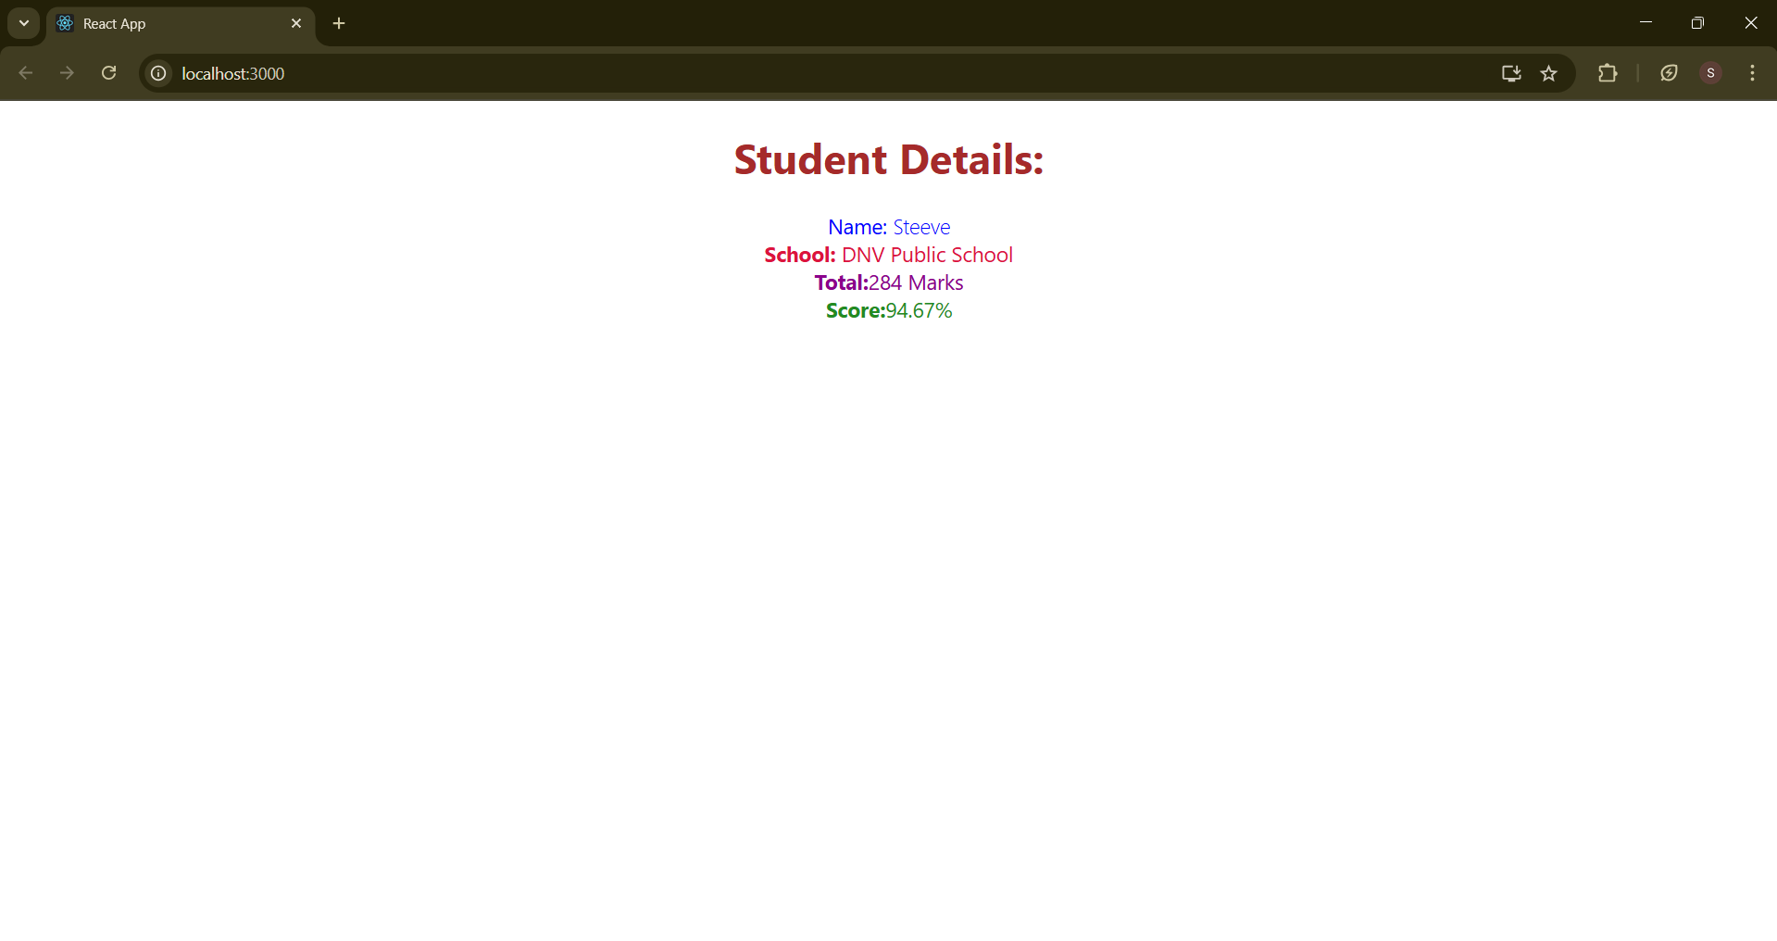

Implement componentDidMount() hook

Implementing componentDidCatch() life cycle hook.

**Post.js**

class Post {

constructor(id, title, body) {

this.id = id;

this.title = title;

this.body = body;

}

}

export default Post;

**Posts.js**

import React from 'react';

import Post from './Post';

class Posts extends React.Component {

constructor(props) {

super(props);

this.state = {

posts: [],

hasError: false,

};

}

loadPosts() {

fetch('https://jsonplaceholder.typicode.com/posts')

.then(response => response.json())

.then(data => {

const postsList = data.map(post => new Post(post.id, post.title, post.body));

this.setState({ posts: postsList });

})

.catch(error => {

console.error('Error fetching posts:', error);

this.setState({ hasError: true });

});

}

componentDidMount() {

this.loadPosts();

}

componentDidCatch(error, info) {

alert('An error occurred while rendering the component.');

console.error("Caught error:", error, info);

this.setState({ hasError: true });

}

render() {

if (this.state.hasError) {

return <h2>Something went wrong while loading posts.</h2>;

}

return (

<div>

<h1>Blog Posts</h1>

{this.state.posts.map(post => (

<div key={post.id}>

<h3>{post.title}</h3>

<p>{post.body}</p>

<hr />

</div>

))}

</div>

);

}

}

export default Posts;

**App.js**

import React from 'react';

import Posts from './Posts';

function App() {

return (

<div className="App">

<Posts />

</div>

);

}

export default App;

**Output Screenshot:**

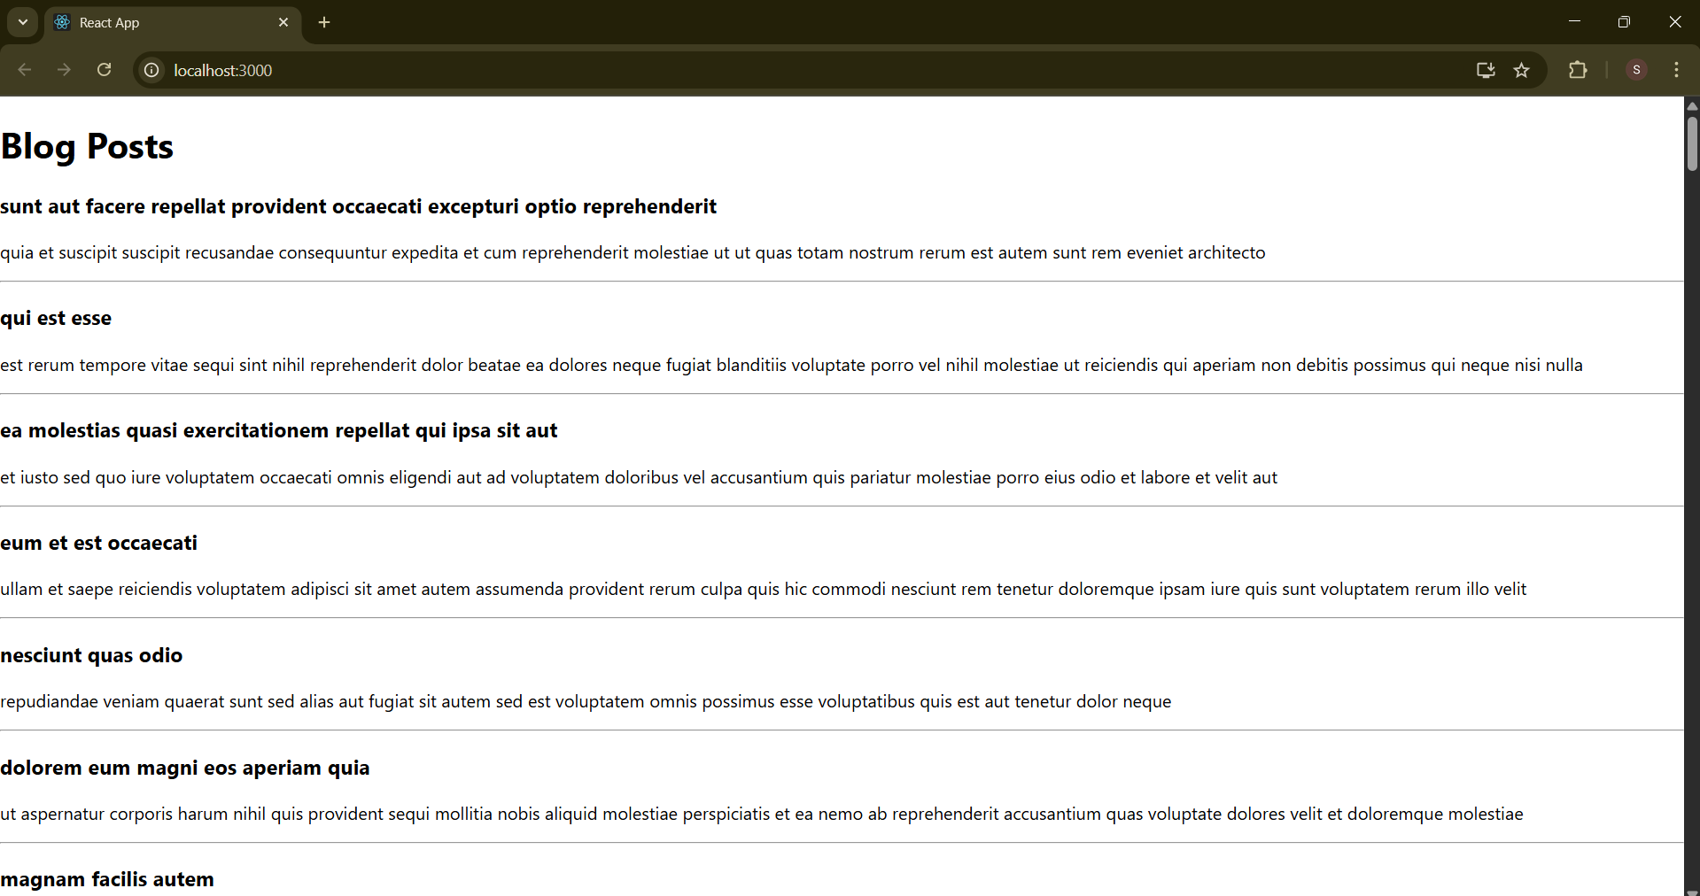

My Academy team at Cognizant want to create a dashboard containing the details of ongoing and completed cohorts. A react application is created which displays the detail of the cohorts using react component. You are assigned the task of styling these react components.

**CohortDetails.js**

import React from 'react';

import styles from './CohortDetails.module.css';

function CohortDetails(props) {

const { cohort } = props;

const headingStyle = {

color: cohort.currentStatus.toLowerCase() === 'ongoing' ? 'green' : 'blue'

};

return (

<div className={styles.box}>

<h3 style={headingStyle}>

{cohort.cohortCode} - <span>{cohort.technology}</span>

</h3>

<dl>

<dt>Started On</dt>

<dd>{cohort.startDate}</dd>

<dt>Current Status</dt>

<dd>{cohort.currentStatus}</dd>

<dt>Coach</dt>

<dd>{cohort.coachName}</dd>

<dt>Trainer</dt>

<dd>{cohort.trainerName}</dd>

</dl>

</div>

);

}

export default CohortDetails;

**CohortDetails.module.css**

.box {

width: 300px;

display: inline-block;

margin: 10px;

padding: 10px 20px;

border: 1px solid black;

border-radius: 10px;

}

dt {

font-weight: 500;

}

**App.js**

import './App.css';

import { CohortsData} from './Cohort'

import CohortDetails from './CohortDetails';

function App() {

  return (

  <div>

    <h1>Cohorts Details</h1>

    {CohortsData.map(cohort => <CohortDetails cohort={cohort}/>)}

  </div>

  );

}

export default App;

**Output Screenshot:**

